A Year in Review

Lindsay Little Theatre had a brilliant year, and as such, we would like to start what we hope becomes a tradition: a year-end wrap up of the directors’ thoughts on the season. We saw many new, as well as familiar faces at all the auditions, and watched our actors grow and blossom in so many ways, so a shout-out is only natural! LLT is generally so humble … but … but … WE NEED TO BRAG!

We also hope this keeps us connected to our audiences with a “behind the scenes” look at what we feel/go through as members. LLT is a foundation for so much creativity and healing in this community, and we are open to everyone!

We asked when directors first came to LLT:
- What brought them there.
- What they found fulfilling,
- what they found challenging and,
- what does it all mean to them ...

Here are the productions/directors in order of performance for the 2018/2019 season:
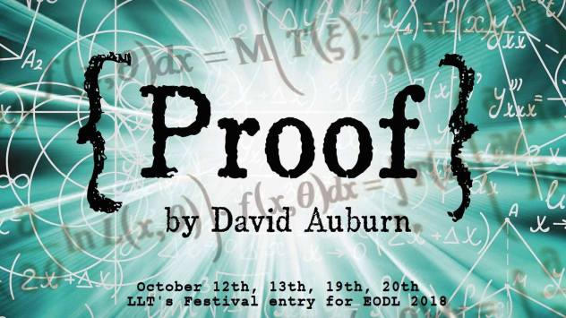
PROOF by David Auburn
Directed by Altaire Gural

October 2018

Altaire - I first performed with LLT in the summer of 2000. Many of us started out helping backstage (that’s safe, right?), or by just dropping our kids off for youth group (phew, still safe). Eventually we found our way ONTO the stage (pardon what now?). We even got brave enough to take on directing something (I’m an idiot)! Some of us go on to write too - I’m now a member of the Playwrights Guild of Canada for my own works, and I attribute that directly to LLT as it was LLT that supported and produced my first play, Forgotten.

Proof was our Eastern Ontario Drama League Full Length Festival entry, and while Anwen O’Driscoll and David Draper (two of the starring actors) were considered not eligible for individual awards due to their professional status, and despite the fact that our set was symbolic at best, we were nominated for Best Production and Best Director, as well as several other awards. Ellen Giddings and Tony Jackson were also nominated for their acting, as well they should have been. This was a four person cast, and they blew the roof off the theatre! The emotional digging we all had to do on that stage together was beautiful, and profound, and will always be one of the highlights of my directing career. We were more than ready a full two weeks before performance, and I don’t think I’ve ever had a production ready that early before. It was magic from start to finish. Did I mention this was Ellen’s first play ever?

Some of you may not know that Lindsay Little Theatre has more of its actors represented on film and television than any other community theatre in all of Ontario. This is a huge accomplishment, and since Proof, Ellen has also gained an agent, and will be appearing in the upcoming October Faction (along with Anwen) as well as Locke & Key for Netflix. Ellen was also accepted into the 3 year acting program at LAMDA in England, bypassing the callbacks! Anwen is about to return to Winnipeg to film the third season of Burden Of Truth for CBC, and David has filmed several commercials and a role for a medical drama. Kylie McCullough (who wrote the song that we used for Proof) just received her ACTRA membership for doing singing/voiceover work for Titans. To say I’m proud is an understatement.
Side note: those windows in the photo below are actually windows from the U of T office of Marshall McLuhan. That was a fun bit of trivia the audience didn’t get to know about!

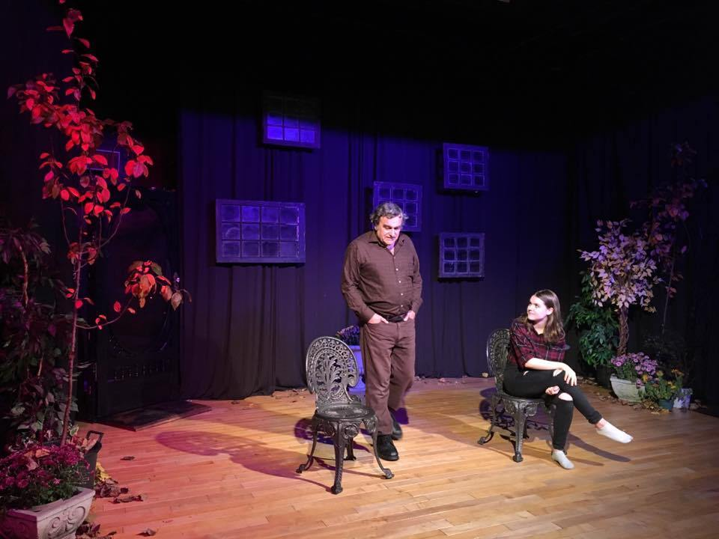

There were bumps, however. Did I also mention we had no lights??? Our lighting system failed and Andre Canivet and I had to go searching for replacements. With Tony’s help, as well as Kathryn and Jeff Condon, and with MUCH trial and error, we got them working (only just). The audience will never know the behind the scenes crazy we all go through to perform these plays, and the sweat and tears we lay down on the stage when no one’s looking, but I like to think it comes through in the final product, and that the essence of our love for what we do shows in our work. At least I hope so. I loved this play, and the people involved.

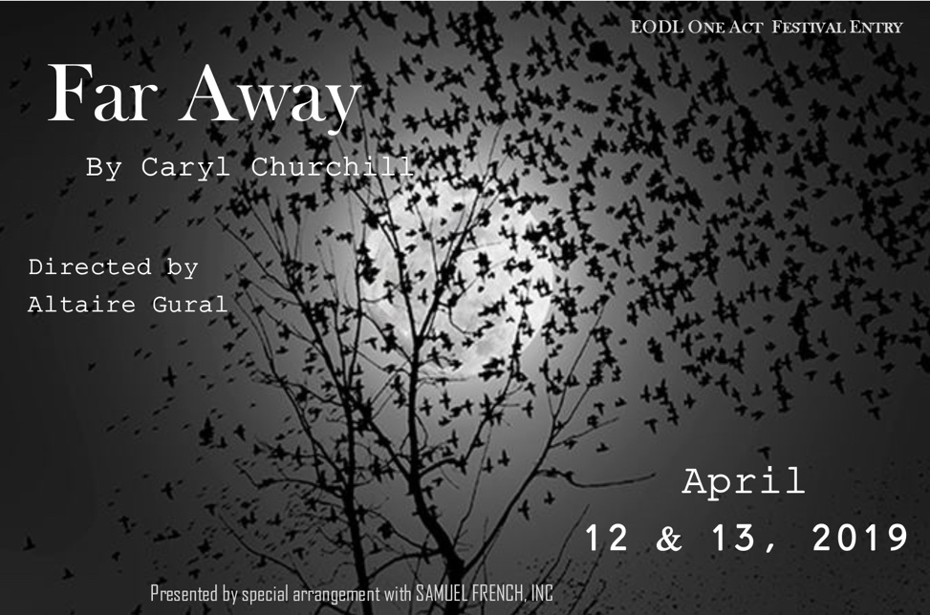

FAR AWAY by Caryl Churchill
Directed by Altaire Gural

November 2018

Altaire - I wanted to try the Eastern Ontario One Act Festival, which is a travelling festival, and so Far Away was our entry. We had three wonderful actors in Ilan O’Driscoll, David Draper and Sheila Charleton, along with probably one of the most bizarre scripts (though very poignant and relevant in today’s political climate). I loved it. The adjudicator said this was a “directors’ play” … I think she meant I was a theatre nerd. I’m not sure if I should have been offended or pleased. I’ll go with pleased.

I learned a lot on this one. I learned that a travelling festival is a very different beast from one performed in the security and familiarity of one’s own theatre. Things can (and did) go wrong (incorrect cues/lighting/wiped out presets which threw the actors). I learned I must be an advocate for my actors, and for their needs. And I will never let strangers alter things last minute ever again. That is something I’ll be telling all directors for future reference. Protect your people and their space. I did learn lovely things from the adjudicator and got to watch other theatres as we were all there (that is something we should do more of, by the way).

Ilan won the Penny Arril award for her acting, and I think I was nominated for Best Director, but that might just be a flawed memory. While we were frustrated that the play performed was not the play we’d brought from home, we did learn from our misses as well as our successes. Probably more so from our misses. Fall down 7 times, get up 8 I always say.
GOODNIGHT DESDEMONA,
GOOD MORNING JULIET By Ann-Marie MacDonald
Directed By Shannon Peters-Bain

November 2018

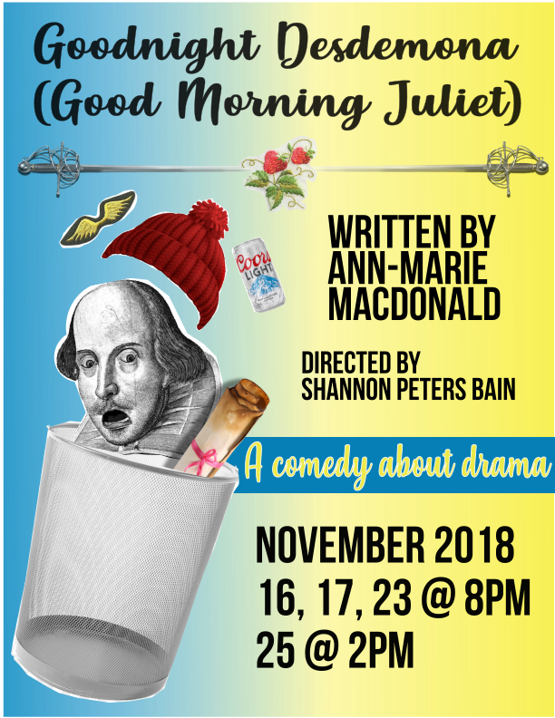

Shannon - When I was young
I played theatre with my friends
I was the director
I produced
I starred
I entertained the neighbourhood
And charged a dime a performance
Then my life became adult
I had to deal with periods
And my parents dissolving relationship
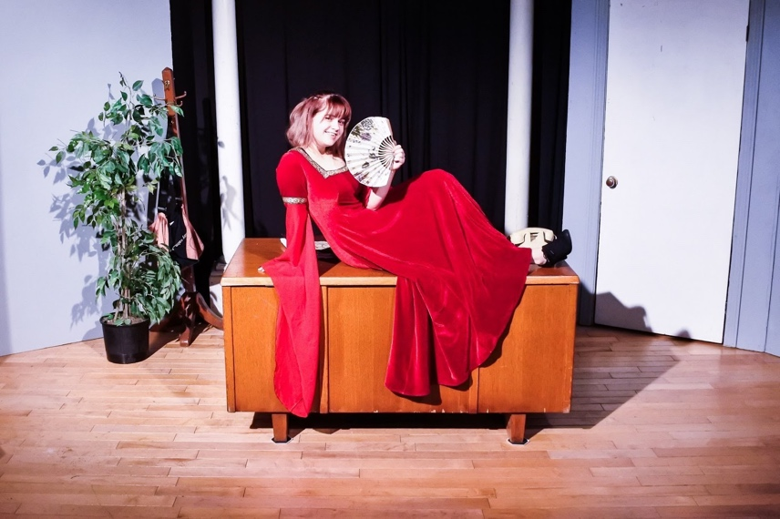
I was not able to play anymore
I had to be responsible
I had to be the oldest child
I had to help everyone else
Sure, I was still creative
I wrote a gallon of sad poetry
I did various artsy things
But usually only got as far
as the sign-up sheet
I ran from the light
Because I lived in such darkness
I ended up in Real Estate
I ended up in Downtown Toronto
I wore heels that made me hobble home
I wore make-up like a mask
I wore black and grey and taupe like armour
I felt like I didn’t get it
IT being the stock market
IT being the need for expansion
IT being the life that I saw rolling out before me
I was suicidal, but could afford to go shopping
So I lived
In that state
Convinced by my mother that life was hard
And enjoying coffee was the best I could hope for
Then I met my future
I fell in love
I got IT
IT being joy
IT being faith
IT being choices - I chose I chose I chose
To wrap my life around this IT
I still enjoyed coffee, but also:
I started searching for satisfaction
It’s funny how near destruction
Can spark a reconstruction

We moved to Burnt River.

By the time I met Pam, then President of LLT, at the Norland Library in the spring of 2016, I had decided to find my way inside a theatre. LLT was on my radar so when I overhead Pam talk to another patron about a play they were in together I jumped and asked for more info. Pam immediately invited me to the upcoming AGM and told me that theatre is the best high on earth.
Say no more. I’ll be there.

In the city I was not a joiner
I was too sad to do anything but
Eat
And shop
And work, work, work, WORK.
And sometimes,
Pretend I was on stage
Pretend I was a writer
Pretend I was ‘living up to my potential’
Which I knew
Without a doubt
Was not Real Estate
How did I come to LLT?
I came a broken soul
How has it affected me?
I am broken no longer
LLT has let me be me
From the second I walked into that AGM
I felt at home
I didn’t know then what I know now
I was about to be adopted into a new family
And in no small way, I was reborn
Or rather
I experienced acceptance
On a grand scale
For the first time in my life
I was able to be myself.

I decided to direct before I found a play. I had been working my way through all the production positions and was terrified and compelled to lead one of my own. The Book Lady of Fenelon Falls gave me plays to read by incredible Can Lit authors and when I read Goodnight Desdemona (Good Morning Juliet) by Ann-Marie MacDonald I knew it was the one. I felt that pull of need, that desperate wish to make this play appear before an audience. The script was intense. I had originally wanted to do a play with a cast of 2, but here was this monster of a play before me and I didn’t argue with destiny; I saved my energy to battle on the stage. The payoff was equally intense when our army of misfits made friends with this monster. All of us willing to be tamed in order to work as one, all of us safe to be wild and adventurous in the world we created together. The size of our cast and crew was the most unexpected gift for me as Director. The cross pollination pushed and pulled me along with everyone else. I think we all grew like weeds - strong and resilient in the right conditions.

The theatre is a classroom.

I remember when rehearsals started I panicked
Oh #*&^!!
They are all going to listen to me when I speak
I had spent so much of my life
Avoiding people, conversation, risk, collaboration…
And here i was COMPELLED to direct?
I had to confront so much of my own fear
I learnt how to cheerlead on a grand scale
I learnt how to rely on others
I learnt how to depend on myself
I learnt that Pam was right:
The high I got from watching every show
I won’t even bother trying to capture in words.
I certainly cried a lot! Happy, joyous, fat, moist, SATISFYING tears.
I learnt that perfection is flawed and still perfect!
Or rather
I learnt that cracks in a smooth surface means you’ve walked over it.
I lead a group of insanely talented humans over a smooth surface
And we cracked the *$&*!! out of it
I followed too
I felt so strongly that although we all had specific parts to play
Each of us lead and followed the others to the finish line
That is closing night.
“Enjoy, we made this for you.”
I heard Alan Rickman say -
I said it too,
before every performance.

I am of the firm belief that a play doesn’t exist without an audience. Which sounds a little obvious, I guess, but I mean it very seriously. We can rehearse as much as we want, but until the theatre is humming with the energy of an audience who doesn’t know what’s coming, well, only then does the play have the breath it needs to really live. I have seen so many people walk into our theatre and have the most delightful time with us. We are like a rollercoaster: Step right up and take your seat on the fantastical ride that is Lindsay Little Theatre! The responses to our productions are always a mix of shock and awe - what we do is mystical if you are on the other side of the curtain. We must never forget we are magicians. We perform before audiences who are ready to be enchanted, to be stretched, to be reconstructed. This is a power and a privilege. Our audiences are intimate and special, and so is our place in the community. I love that we have been an undiscovered gem, but I am convinced we are about to witness our ascent from obscurity.

The family we have expanded and strengthened at LLT during the last season is a formidable force of art and creativity. At LLT we all mentor and participate and cheerlead and outreach; it is only a matter of time before we reach a tipping point of notoriety. We were all born for this, or reborn because of it. We are on stage and in the audience. We are supporting seasons between our tree trunks of talent, and every year we grow taller and soon we will be impossible to miss.

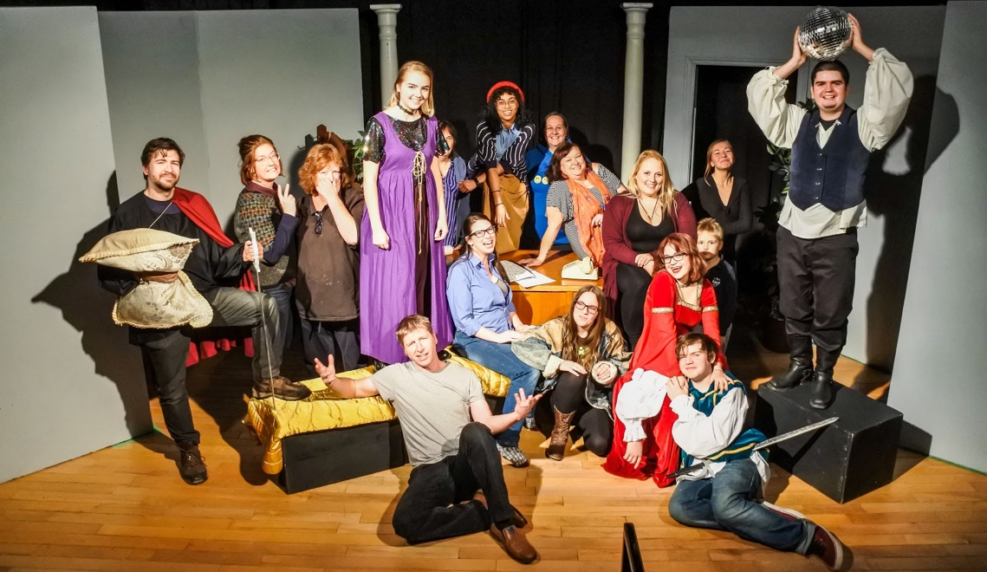

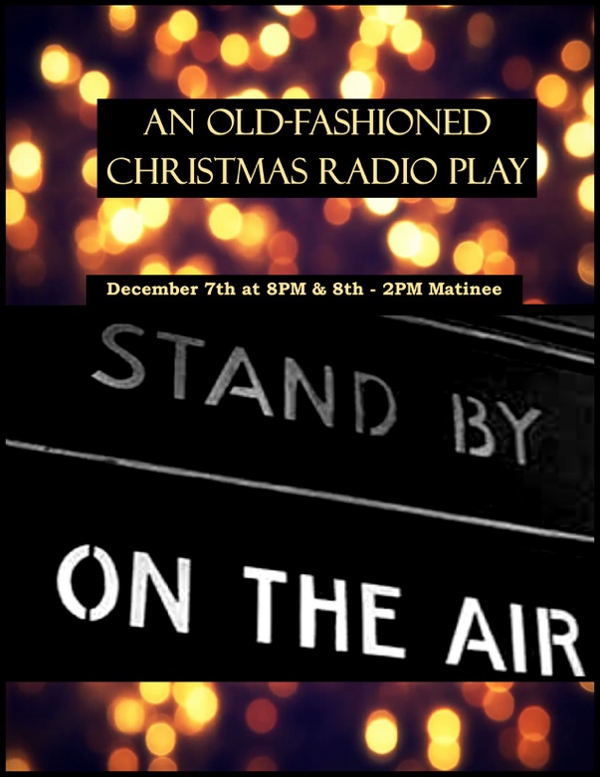
CHRISTMAS RADIO PLAYS
Directed by Seamus McCann & Holly English
December 2018

Seamus - In November Holly English, Marion Bay and I volunteered to fill in as co-directors for our upcoming radio show, and we were all excited to try something new. I personally have directed a number of shows over the years but it had been a while, so I thought it would be a fun project. The pre-selected scripts were Father Knows Best and My Friend Irma. The idea was to make it visually interesting, get people involved in the story, and have the audience feel the nostalgia and bring people into the Christmas spirit. As we only had a short time to rehearse (two weeks) we quickly put together a cast of new actors as well as veterans of the stage of all ages. The concept was to have a show within a show: the audience would get to watch an actual radio show being produced in studio, so our actors had to find characters to stick to for the length of the performance, and then also had to read as different characters while on “radio”. Everyone stepped up to the challenge!

I was also in charge of sound effects, and I wanted to make as many sounds on stage as I could without having to use sound effects over the speaker. Holly worked on set design, creating an ambience, and Marion worked on sound and lighting in general. It was a great combined effort. The shows were well received, and the audience enjoyed hot apple cider and goodies during intermission. Everyone had a great time! I look forward to more involvement in future Christmas productions.

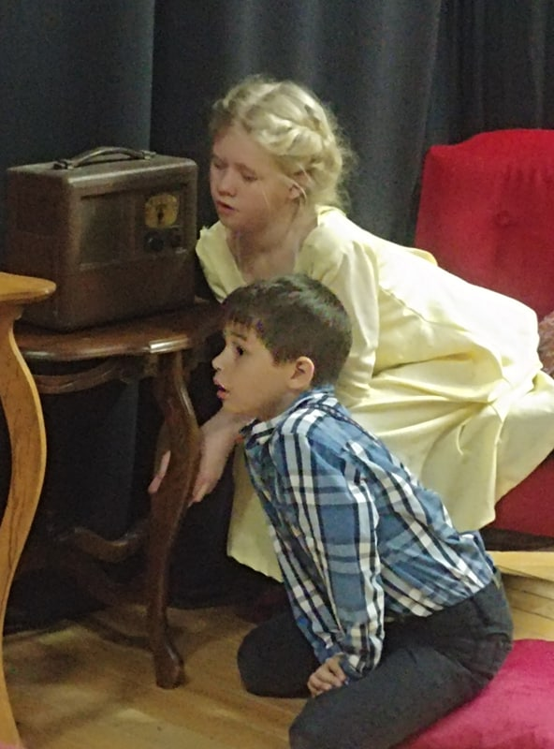
Holly - I joined in the LLT fun back in 2015, when I auditioned for The Odd Couple- Female Version, directed by Caren McNeilly. Playing the role of Vera allowed me to get back to my theatre and comedic roots, reigniting my love for the stage and live audience energy. Since then I have been so grateful for volunteer opportunities within this theatre community, and in this particular role, as a part of the direction and production team, I was able to learn so much about being behind the scenes as well. Having the opportunity to take this project on, alongside Seamus, Marion, and Chris, was an all-around wholesome, eye-opening, and fulfilling experience to say the least. With their encouragement, creativity, accommodating and organized approach, I felt like I could truly be myself, focus on my strengths, while learning so many new skills concerning direction and production too! Collaboratively we directed, focused on sound effects, stage management, set design, scheduling rehearsals and costumes. The whole cast had major input during the process, adding pizzazz to every detail of this stage adaptation.
Due to being a stage performance of a radio program, we had the unique chance to re-create a time when computers did not do all the sound and editing work behind the scenes. We were able to research and focus on how a group of talented, creative professionals would produce sound effects and voices, and show their perspectives and emotional dispositions in that way. By removing the fourth wall of the radio station’s studio and from the family home, we tried to create a new visual experience for those in the audience that remember radio programs while also creating a new conceptual experience for our younger audience members.

Our actors were eager to take on the many lines and roles, as well as create their own silent, humorous, defining characteristics, adding layered dynamics within this old-fashioned Christmas Radio Play stage production. Thankfully, I was also playing a role in the first act, adding to my joy in this festive season experience!

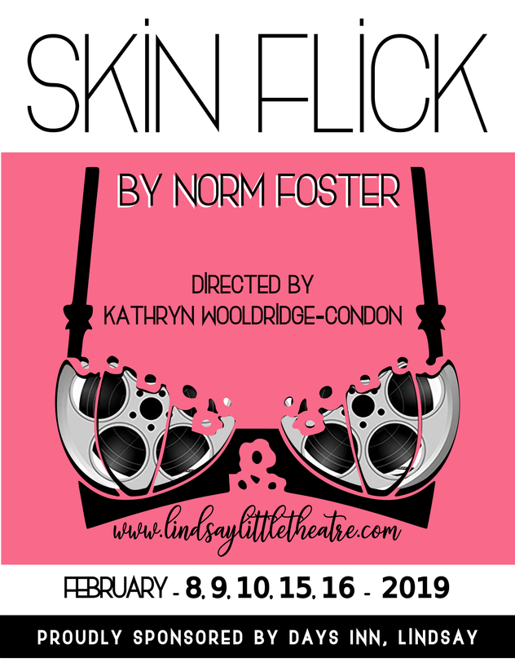

SKIN FLICK by Norm Foster
Directed by Kathryn Wooldridge-Condon
February 2019

Kathryn - I came through the doors of Lindsay Little Theatre when a friend from a knitting group I was in asked me to come and see a show they were directing. It was called Kiss the Moon, Kiss the Sun. I was entranced. It turned out another friend from the knitting group, Miranda Warren was in the play. I spoke with her about how floored I was and how much I enjoyed myself. Shortly after that Miranda approached me about stage managing a play for LLT—The Odd Couple (the female version) by Neil Simon. This was in 2015 and I have never looked back. LLT has helped me bring my creative side back to life. That to me is precious. I thought it was gone and never to return. I was also struggling with depression and anxiety during that time. I was becoming more and more withdrawn, and I truly believe my work at LLT has helped me manage it and kick it to the curb most days.

My first show was the best experience I could have ever asked for. Director Caren McNeilly was an inspiration to me right away. She was patient and really showed me how to do my job well. It was a prop heavy show with a fantastic cast that had chemistry and was so much fun to be around. From there I stage managed a bit more then realized I needed to direct. I wanted to try it and was given the opportunity when Nick Payne’s Constellations came along. Taking to the stage as an actor soon followed. My love now lies with directing and I look forward to next season already and being able to bring more of my heart to the stage, directing two productions and mentoring on a third.

Looking back on the last season at LLT has given me pause. OMG I grew so much! In some aspect, I worked on most of the shows that happened. What a whirlwind! I learned something new on each show. I was honoured to be a liaison for Proof (our festival entry show) for EODL. It was an eye opening and wonderful experience. I could not be more proud of the cast and crew on that show. They represented LLT with class and poise and the show was BRILLIANT! Producing Goodnight Desdemona, Good Morning Juliet! brought me together with Shannon Peters Bain once more. She is one of the loveliest and smartest women I know. The cast on the show had so much energy! I found myself admiring everyone and their hard work. I have never really worked closely with youth before at LLT and I was blown away by the talent and the size of their hearts.

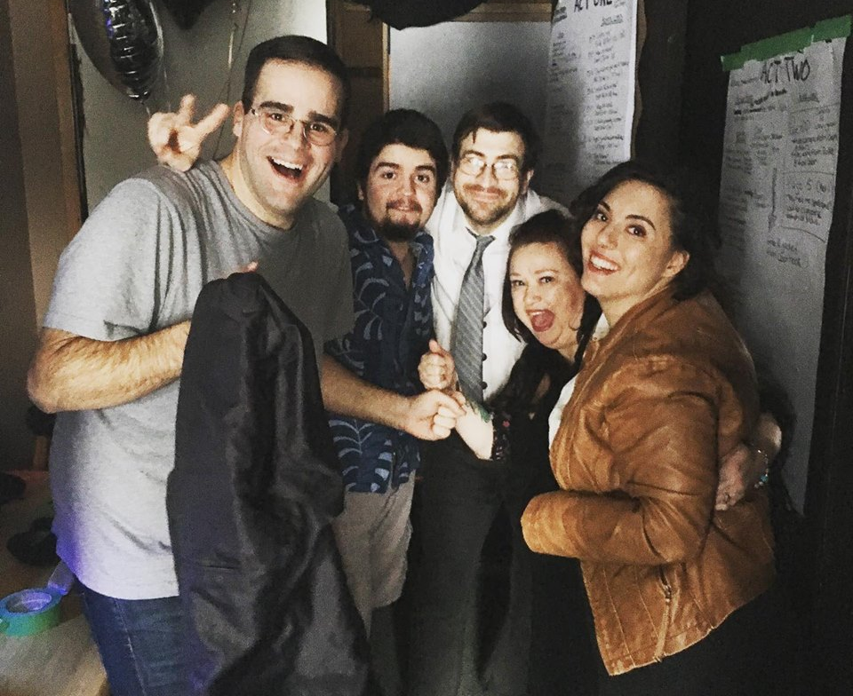
I chose Skin Flick by Norm Foster to direct this past season because quite frankly, it had me in the first two pages. I found myself laughing out loud and my vision was forming immediately and solidly. I was falling more and more in love with every page and knew I had to do this show. If you know me – you know I was meant to do this show. I could do the script justice! I have never felt so sure before. No doubt. The cast and crew on the show were incredible. EVERYTHING FLOWED. We all worked our butts off and seemed happy to do the digging and the long hours to bring the show to the stage. The chemistry was there from the first read through. We really worked as a group. Everyone’s input mattered. The final product was one that had audiences in stitches. I was certainly proud of it. I still can’t stop talking about it. We really worked as a team and the cast and crew were open to trying new things and we had the best time on photoshoot day! The challenges that came with doing a romantic comedy with such a spicy topic was bringing it to life in a fun naughty way and not in an offensive way. There were certain choices I made as a director that were meant to provoke (very suggestive sound effects to some of the physical comedy choices) and I think we accomplished a show that was fun from start to finish.

We also had to do a lot of work around the topic of intimacy. Our stage at LLT doesn’t allow for much space between the actors and the audience so it was a challenge creating the safest level of intimacy we could. We worked behind the scenes broaching the topic of intimacy with care and respect towards the actors and for their significant others as well. It was a difficult challenge for sure. The individualism of each cast and crew member also creates challenges as a director. To learn to communicate effectively with each member of the show required constant adjusting of my teaching style and making sure I was an effective listener. HUGE shout outs to the cast and crew – Colette Marshall-Schroter for bringing an edge and sassy quality to Daphne, Andre Canivet for portraying Rollie with an innocence and goofy charm. Collin Dusome for taking Alex and making him into a loveable flawed character. He is a true comedic genius. Sophie Kourtsidis played Jill to perfection. I wanted the character to not be typical. I saw her as strong and hilarious and boy did Sophie deliver! Dylan Robichaud added so many touches to his gentle naïve character that made everyone fall hard for Byron. Nate Copeland stage managed and KNOCKED IT OUT OF THE PARK, Meg Duncan showed once again that she is the queen of costumes. Katisha Shaw rocked makeup and hair and was a calming upbeat energy for the cast, Sam Smith and Tyrnan O’Driscoll rocked light and sound for the show and if you know me or have been to any of my shows, then you know curtain call is a THING! I cannot say enough positive things about my producer Shannon Peters Bain. She is a light and so so so creative! I am forever grateful to the loved ones in our private lives that help boost us and keep us sane during these productions. They are so valuable and appreciated.

Closing thoughts on the other parts of the season:

Acting in Kaleidoscope (see pg. 13) was a choice I made to “add tools to my director’s kit”. I knew working with Altaire Gural would provide me with a whole new set of skills I could bring to future directing endeavours. It was a humbling experience and I dug deep to flesh my characters out. Altaire was patient with me and really brought me out of my shell. Colette Marshall Schroter was a ROCK for me in this process. It was so odd to go from directing her to acting with her and I am so proud of what we accomplished together. Acting with Nate Copeland was intense. I have never worked so hard in my life to quell my own personality to get to the root of my character. Nate was doing the same on his end and I am floored by the end result. Logan Gerzymisch and I have known each other for years and often joked that I am her second Mom. We got to play mother and daughter in our scene and she blew me away. I love this kid to the moon and back.

Producing Breakfast Club (see pg. 11) and supporting Logan’s first directorial effort made my heart very happy. And of course, my experience on Barefoot in the Park was ground-breaking. Nate Copeland and Meg Duncan brought a fun and new take on the aged play and made it fresh. Puck Leggat did an amazing job their first time stage managing too! Jeff Condon even took to the stage for the first time and is now in rehearsals for our fall play! The cast really made the audiences laugh and I loved hearing all the positive comments from audiences on intermissions.

I hope this next season is even better than the last. We have changed our ticketing system and have taken steps to improve our social media presence. This should help get our brand out and I hope the community can look to Lindsay Little Theatre to provide them with quality shows they can rely on. I am also thankful for every business that has sponsored us this season. It has been wonderful for us! I am proud to sit on the board of this amazing theatre. I guess this is the long way of saying that the people that make up Lindsay Little Theatre are my heart. They are magic and they have become family.
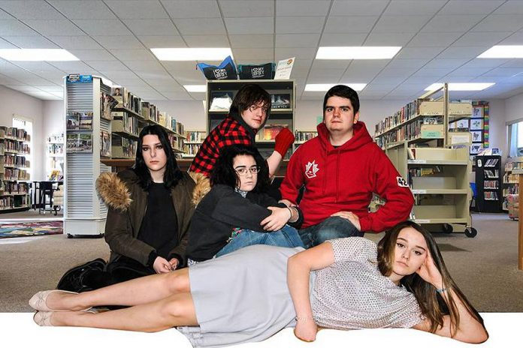
THE BREAKFAST CLUB by John Huges, adapted for stage by Altaire Gural (with the permission of the estate of John Hughes and Universal Studios).
Directed by Nathan Copeland and Logan Gerzymisch
March 2019

Logan - I first came to LLT in 2016 and helped with Waiting For The Parade, I was assisting as front of house for volunteer hours, but I had no idea then that LLT would end up becoming my home away from home. LLT has affected me in so many ways, my confidence has grown since coming here and I’ve made so many connections with so many different people.
When I decided I wanted to try directing, I searched for a long time for a play that would involve more teenagers. I really wanted to get more people my age involved so they too could experience how amazing LLT is. The play I originally proposed to the board last year ended up not working out, which is when LLT’s very own Altaire Gural offered her adaptation of The Breakfast Club. When looking for plays, I had The Breakfast Club in the back of my mind the whole time, but I had no clue we had a version of the script to use. When it came down to deciding my co-director Nate Copeland and I knew that it was the obvious choice.

While directing I had a lot to learn. I learned that our stage is small and in order to make a set work you have to get really creative, which we did. But mostly I learned that working with your fellow peers, though fun and exciting, it can also be a challenge, especially since I was younger than all of my actors. It was stressful, I’m not going to lie, there were many times I thought to myself “will this even work?” but with a lot of hard work and many long days spent rehearsing, we pulled it off.

Having The Breakfast Club as our play gave us a few challenges though, such as having to make the actors forget what they’ve seen in the movie and have open minds to new ways of showing each character for who they are..There was also the number one challenge when working with teenagers, especially teenagers that don’t have cars: getting to and from rehearsals. Since every character is in every scene, it was hard when we didn’t have everyone. Our second rehearsal, we had exactly 3 of our cast members because the rest were unable to get rides in to the theatre. Luckily, all the adults on the production team were so unbelievably generous and offered rides to and from for members of the cast who couldn’t get a ride in. And to everyone who ever drove around a theatre kid back and forth 2 to 3 times a week, I am forever grateful.

I’ve always said that LLT is my family. That small stage is magic and it brings people together. We’re growing and now more than ever, people need theatre in this community. Theatre can bring out the best and worst in people. I like to think theatre and all the amazing people at LLT have helped me become who I am today. I had people come up to me after they watched “The Breakfast Club” and they were amazed that I had directed something at such a young age, but I’ve been surrounded by the most professional, fun, and encouraging people for almost 4 years now and I’ve learned something from each of them. At LLT there’s always someone to ask for help if you need it, there’s always a shoulder to cry on and there’s always someone who will make you laugh. Audiences can sense that when they walk in, they can sense that we’re a family because it comes through in our plays. The audience doesn’t see the months of rehearsing, but they know it happened because our hard work shows whenever we’re on stage. I think LLT offers something no other theatre does, and that’s a family experience whether you’re on or off stage.

I only have 2 more years before I go off to school and won’t be able to be at LLT for every show, and as sad as that is, I’m happy to know that when I come back it will always be there, and so will my amazing theatre family. LLT isn’t just for actors, directors, stage managers, or producers, it’s a theatre for everyone. LLT is so much more than just a theatre. It’s where I made some of my closest friends who turned into family, it’s where I started acting, and directing, and working backstage. It’s where I’ve spent so many nights at rehearsals working so hard to help put on an amazing show. It’s where I’ve grown into the person I am today, and it’s where I hope many more people get to grow and have an experience as amazing as mine. It is and always will be my home away from home.

Nate - co director - Everyone has a different reason for joining a community theatre and for me, it’s the community part specifically. I love this opportunity to bring quality entertainment to our little town as well as contribute to the arts within. What I am most passionate about is building our community within the Lindsay Little Theatre and helping people find a place where they belong. I’m fairly new to LLT and when I co-directed The Breakfast Club I hadn’t been a member even a year. In that short time, I had received so much support from other members, which contributed to a tremendous amount of personal growth for me. As a transgender man this level of acceptance and support is invaluable. I wanted to bring this experience to other people in the greater community who might also benefit from this kind of opportunity. When Logan Gerzymisch, my fellow co-director and Kathryn Wooldridge-Condon, the producer began talking about putting together a play for young actors, I wanted to be part of it.

As a director, I wanted to encourage and support a cast of predominantly young actors because typically there aren’t a lot of roles for teenagers. Logan herself is a teenager and in the time we had worked together on previous productions backstage, I was blown away by her passion and dedication to the theatre. The Breakfast Club brought a lot of new actors to our stage. It was amazing to see how much they developed their skills over just a few months of rehearsals. I watched as they overcame their fears and pushed themselves outside of their comfort zones, which as you will learn from The Breakfast Club itself, isn’t an easy thing for teenagers to do. There were also a few experienced actors in the cast who guided and mentored the new actors, giving our set an all-around sense of community. I was right there with the actors taking on a small role and stepping foot on stage as a first-time actor myself. I would also like to mention that I don’t know what we would have done without the organizational skills of our stage manager Chris Macaulay, and I’d like to send my greatest thanks to Altaire Gural for writing this amazing adaptation and for her mentorship in directing. Not every moment was easy, but we worked through the difficult moments together and had an amazing production at the end to show for all our hard work. Even more important were the lessons we learned, the fears we overcame and the connections we made.

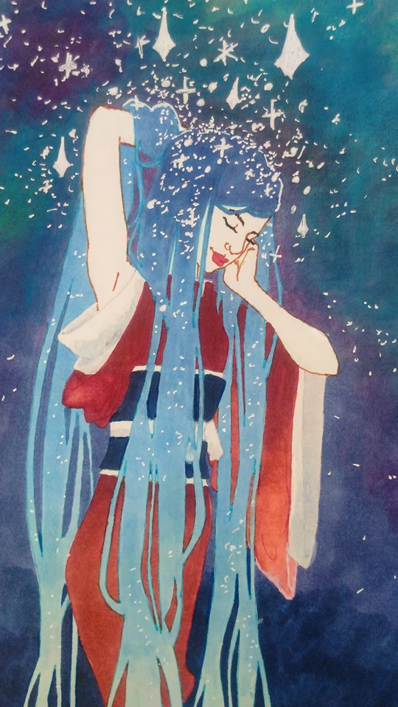
KALEIDOSCOPE ll (K2)
Directed by Altaire Gural
April 2019

Altaire - We were supposed to reprise Far Away for an LLT audience, but because our cast was so small, and it was only a one act, I felt a different project was in order. I decided to bring back Kaleidoscope, which is essentially a workshop of scene studies. We had a cast of almost 30 actors of various ages, varying levels of ability, some with anxiety, and everyone learned they have brilliance in them. I’d invited Sam Tweedle of Kawartha Now to sit in on auditions and rehearsals so he could get a real sense of the scope of a production. He was floored at the end result. Even the most timid auditioners performed with bravery, depth and honesty when finally in front of an audience. Rehearsals were magical spaces where people could try new things and combat their stage fright in remarkable ways. I always love my rehearsals, and it was a joy to watch the young actors let loose, and the older actors conquer their inhibitions. I hope other directors will step up so this can be an annual or bi-annual production as it’s a hit with the actors.

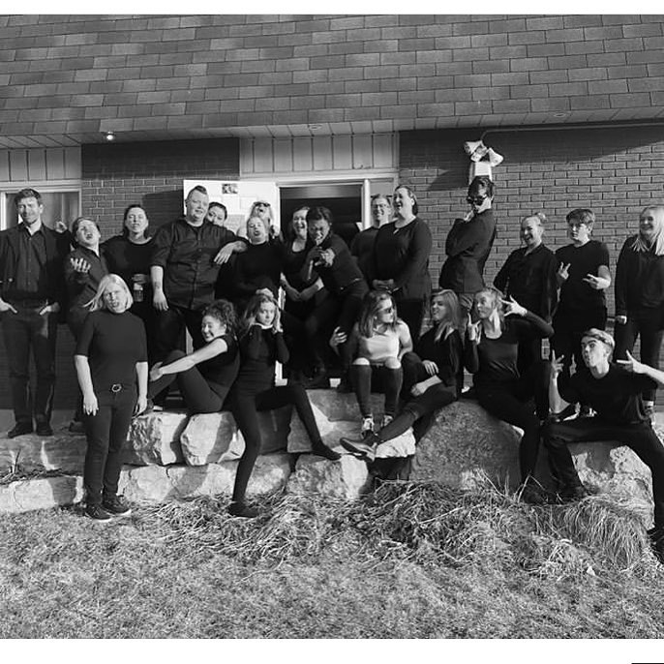

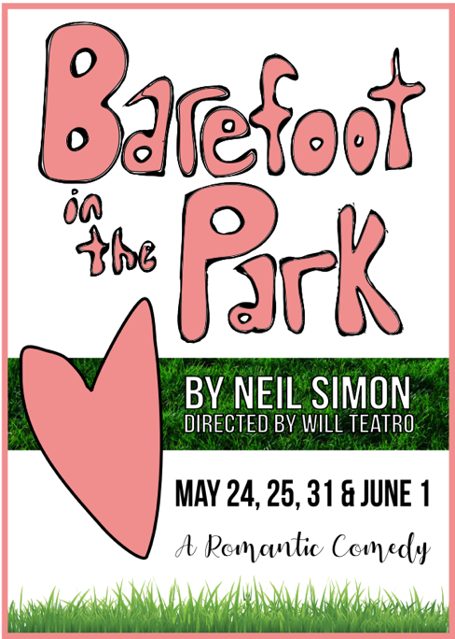
BAREFOOT IN THE PARK by Neil Simon
Directed by Sophie Kourtsidis
May 2019

Sophie - I first came to LLT in 2012, left to do other life things, and returned in October 2018 to see Altaire's production of Proof. Standing on the stage with the actors after the show, I had a “come to Jesus” moment; I realized this was the path I had to take - to be a creative, an actor, director. To me, and many others, LLT is family. To the community, LLT is the future. A place full of possibilities, opportunities, and hard, fulfilling work. LLT is ground zero. I was fortunate enough to be granted the opportunity to come into a play with a cast that was already in motion. (This had its own set of challenges and rewards. Mainly, I didn't choose the material or cast). I was lucky that I understood the play and had a group of actors who were willing to dig deeper, try new things, and adapt to all the changes very quickly. I learned that it can be hard to remain professional when you're so personally invested. Directing is high stakes; to do it well you have to have a strong vision, sure hand, and good communication skills. There's a lot of nuance that goes into leading a group of people, and I knew that as much of a learning curve as it was, directing is something I will do for the rest of my life.
On a personal level, I found I still have a lot to learn and work on, and I'm forever grateful for this experience showing me where I can grow and offering the safety to do so. Having no control over what you're tasked to lead can feel akin to becoming captain of a ship in the middle of a storm. I had to learn how to accept limitations and be assertive with absolutes. The set for example: there was one piece that took 4 hours and eight people to put up. It was taxing but I never questioned that it was the right move. Many of the actors, talented as they are, were new to performing and, like myself, had to learn to trust themselves and the process of working creatively together under time constraints. Audiences are great (can't have a show without an audience), always receptive, with good energy. Part of being an audience member is allowing yourself to be moved by what you see on stage, allowing yourself to be open to the possibilities of pretend and engaging with it in a way that creates a meaningful, connective experience. Artists can art all day, but it's the audience that makes them feel seen. We're lucky to have such supportive people come out and help keep the lights on.
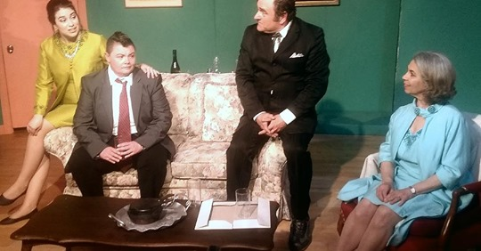
CODE OF CONDUCT by The Cast
Directed by Dave Cave
June 2019

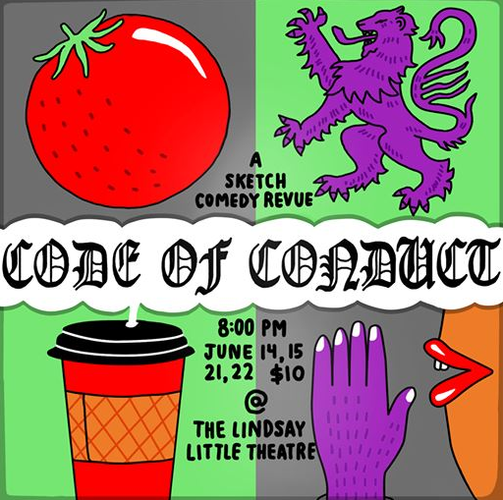

Dave - I first became involved with LLT as a teenager during two summer Renaissance Fairs. Being one of the most enjoyable moments of my life, I decided to not act for almost a decade. I began stand up and sketch in Toronto, and when I returned to Lindsay I wanted to reconnect with the theatre. Stand up can be lonely, I wanted to work with a group again. The sketch comedy revue was described by the cast as more of a workshop than a series of rehearsals. I learned how tapping into real insecurity, real shame, the real lives of the cast developed a show where audiences saw themselves on stage. Myself and the cast did not grow by being comfortable. To be comfortable is to die! Our limited schedule and minimal comedy experience was a perceived barrier initially, but process is product. I see LLT as a central hub for storytellers in the Kawartha’s.
And remember, the audience is always right.
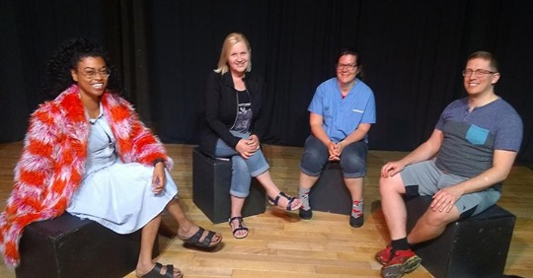

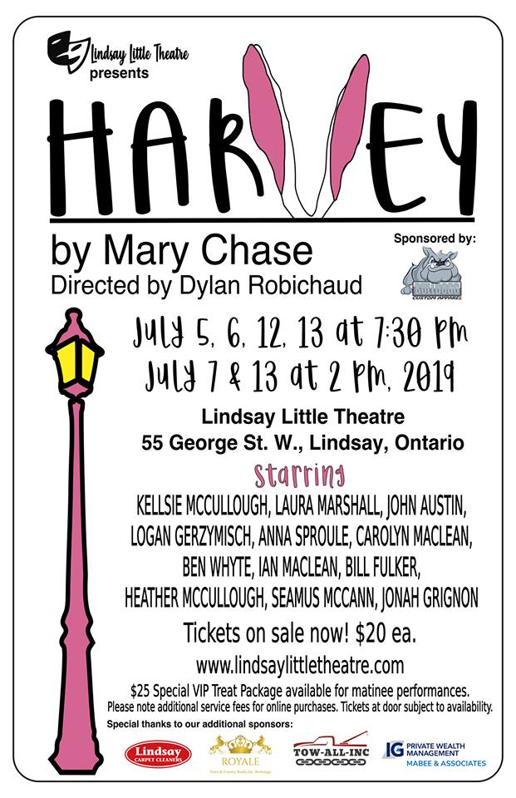
HARVEY by Mary Chase
Directed by Dylan Robichaud
July 2019

Dylan - I have been in love with Harvey for as long as I can remember, and so naturally I have spent 2 years (my whole time with LLT) trying to get it to the stage. I couldn’t stop talking about Harvey, and I am sure everyone wanted me to shut up about it. My vision for Harvey was big (and with a cast of twelve, rightfully so). I had a full year to plan, and plan is what I did. I had the whole year marked up with how we should bring the co-production to the Academy Theatre. Here is the thing with planning: sometimes your plans don’t work out. If being in the military has taught me anything … have a plan A, plan B, plan C … right up to PLAN Z. Make sure you are prepared. I certainly was not prepared to have my whole production switched and rearranged with only six weeks out. However, that’s exactly what happened. At the time I was devastated. I had prepared and envisioned a large show for a large stage. Then came the challenge to scale it back.

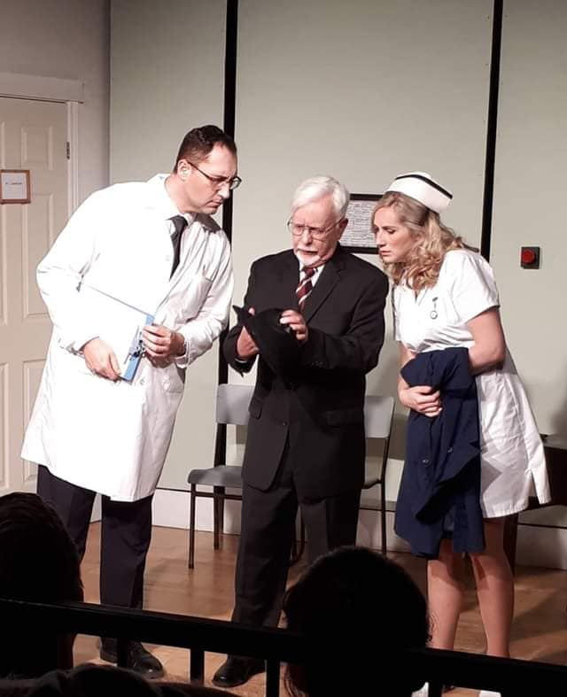
Here’s where I lucked out: the venue change (which I viewed as a challenge) actually became an opportunity. We, as directors, need to constantly be looking for these moments throughout our show’s rehearsal process. For me, I was so set on one vision that I wasn’t making the creative process too much fun. HOWEVER, once we had the opportunity to re-work the show, the possibilities were endless. We reimagined and reworked how we could use LLT’s space to the fullest. I believe we achieved that nicely.

My set was another challenge. I had again envisioned something BIG for the Academy stage. However, with the new opportunity we ended up creating a lasting legacy for LLT. I wanted to be able to show that we were in two distinct places (the Dowd library and Chumley’s Rest). I wanted the audience to feel transformed when we took them to each location. That is where I had my idea for spinning sets. Thanks to Jeff Collins who took my crazy idea and made it into sketches and drawings, letting me know how we could make the set successfully. A HUGE thank you to Jim McCullough who took my idea, and as I asked him if he could build it, said “This would be EASY” … I don’t think it was as easy as Jim thought. Many late hours and days spent at the theatre, but the end result was outstanding. It was evident as audiences each night remarked just how lovely the set was. So, thank you to Jeff, Jim, and EVERYONE who made my Harvey set into a reality. It certainly was a lot of blood, sweat and tears, but in the end … it paid off!

When we take on the role of directing, we never really know what we are getting ourselves into. We don’t know how this creative process is going to come together, but I certainly lucked out. The cast of Harvey was so much fun to work with. They were all dedicated to bringing Elwood P. Dowd’s world to life. I had 37 people audition for the show, and with most roles I knew right away that I had found the right people for each part as soon as they walked into the audition. That is a director’s dream!

We had a crew that was top notch and who, without their help, this show would never have happened. They too spent countless hours preparing the lights, sounds, props, art work, etc. Their attention to detail was next to none. As a director, we often get caught up in the actors. However, having key people who pay attention to the small details, your show can be taken to the next level. I think of Ian Maclean who made our two very important portraits for the show. What an incredible work of art those two paintings were. Directors need to keep in mind that throughout the creative process many people will bring many different talents and gifts to your show, especially here at LLT where talent seems to be never-ending. Heather McCullough also played a huge role in gaining sponsorship and making our matinee shows extra special.

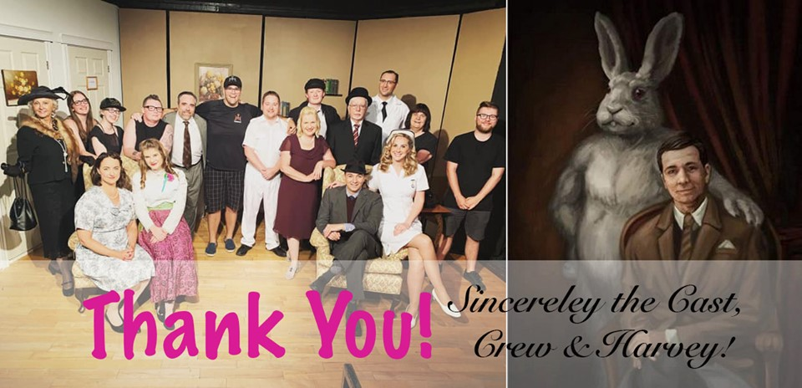
All in all, I know that it takes many people many hours to bring a production to life. Without teamwork none of this would become a reality. So, as I reflect on my show I can’t help but just think of how grateful I am for the talents we have within our theatre. Harvey is over … after 6 SOLD OUT performances … and with it our 2018-2019 season at LLT. But what’s exciting is the new possibilities that each new season and each new show bring with it. We learn from the past and encourage anyone who wants to be challenged creatively to look at these challenges as opportunities, embrace them, and wee what new wonderful thing they will bring to your production. I DID! And it worked out wonderfully with Harvey.

